Name : Mohamed Waleed Hamdy

B.N / 830

Date /

Topic : Artificial Intelligence

Application Brife:

Screenshots:

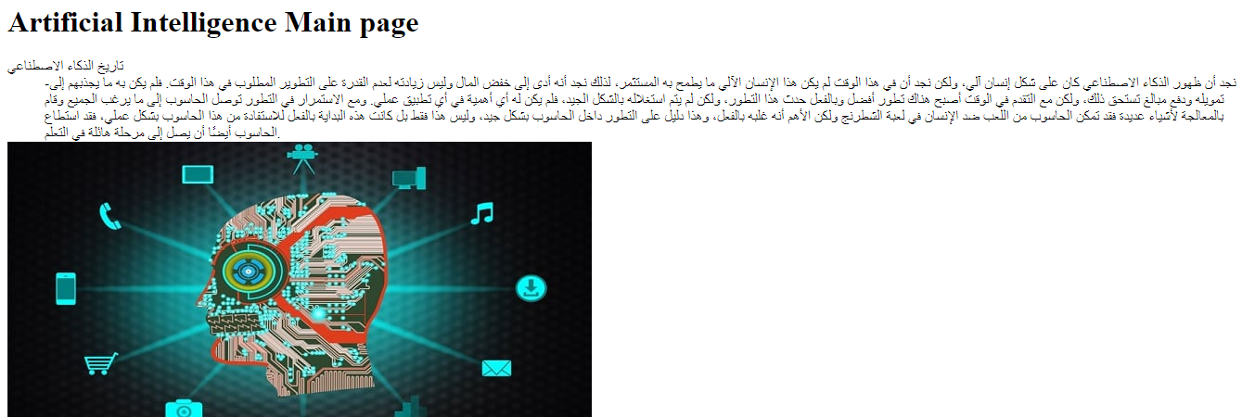

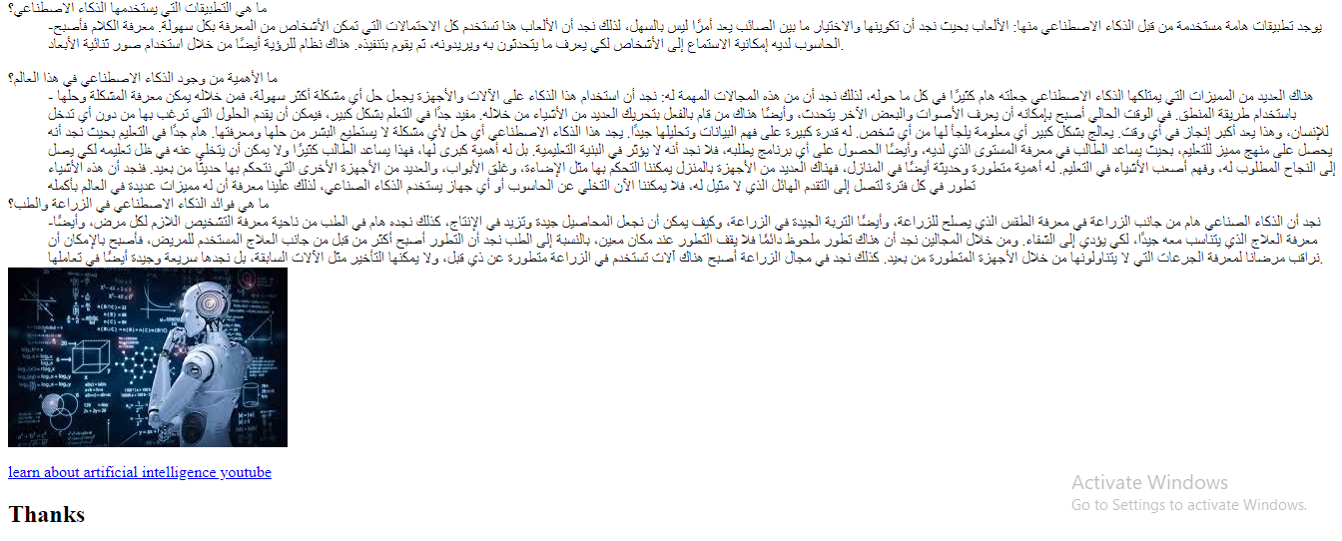

Source code :
